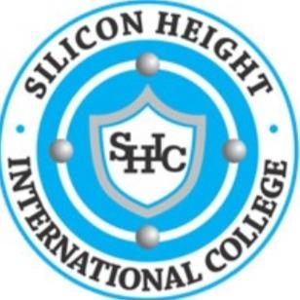
SILICON HEIGHT INTERNATIONAL COLLEGE
(Developing functional digital skills)
No. 1 Turaki Sani Stores Road, Commercial Layout, Gidan Dawa, Katsina
2025/2026 Academic Session: First Term Activity Planner
Weeks | Days | Date | Activities
1 | Monday | 1st September, 2025 | Resumption
1 | Thursday | 4th September, 2025 | College Policy Awareness
 | Friday | 5th September, 2025 | Eid-El- Maulud
2 | Thursday | 11th September, 2025 | Carrier Counselling to all students
3 | Mon-fri | 15th-19th Sept, 2025 | Lesson continues
4 | Mon – Fri | 22nd – 26th Sept, 2025 | First C.A Week
5 | Wednesday | 1st October, 2025 | Nigeria’s 65th Independence day
5 | Friday | 3rd October, 2025 | Inter House Quiz Competition
6 | Friday | 10th October, 2025 | Spelling Bee
7 | Monday | 13th October, 2025 | International Cancer Day
7 | Wed – Fri | 22nd – 24th Oct, 2025 | Mid Term Break
8 | Mon – Fri | 29th – 31st Oct, 2025 | 2nd C.A Test
9 | Mon – Fri | 3rd -7th Nov,2025 | Lesson continuous
11 | Thursday | 13th November, 2025 | Inter Class Debate Competition
12 | Friday | 21st November, 2025 | Inter House Sport Competition
13 | Mon - Tues | 24th – 25th Nov, 2025 | Revision
 | Wednesday | 26th November, 2025 | Commencement of Examination
14 | Mon - Fri | 1st – 5th December, 2025 | Continuation of Examination
 | Friday | 5t^{h} December, 2025 | End of Examination
15 | Thursday | 11th December, 2025 | Collection of exam parcel
 | Friday | 12th December,.2025 | Vacation

